Linux Environment Variable Assignment

- Create a script named “myscript” in current directory to do the following.
- create a dir named “subd1” in current directory
Ans) mkdir subd1
- create a file named “dircontent” with contents of the current directory
Ans) ls>dircontent
- display the contents of the file “dircontent”
Ans) cat dircontent
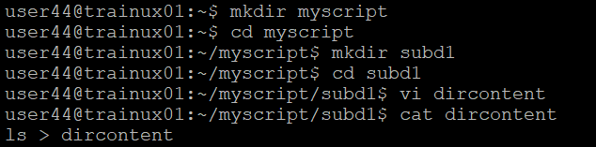
- display the contents of a non existing file named “unknownfile”
Ans) cat unknownfile2 >/dev/null
- Run the script and validate the output in following cases
- Redirect only the stdout to an o/p file named stdout.txt
Ans)./myscript > stdout.txt
- Redirect only the stderr to an o/p file named stderr.txt
Ans) ./myscript 2 >stderr.txt
- Redirect both stdout and stderr to an o/p file named stdall.txt
Ans) ./myscript > stdall.txt 2>&1
- Display all o/p and error and also redirect both stdout and stderr to an o/p file named stdall.txt
Ans) ./myscript | tee stdall.txt
./myscript 2 >&1 | tee stdall.txt

- Redirect the output of command below using pipe (|) to wc and get the output .
ls -l
Ans) ls -l | wc -l

